Jan Dudek, 286161

**1st Report**

**Introduction:**

The purpose of the project was to develop software created in previous project by adding new features, including Monte Carlo microstructure generation, possibility to use Monte Carlo method along with previously developed ones and generation of microstructure by static recrystallizing existing structure

**Technology stack:**

For creating the project C# language was used, along with Windows Forms framework. The choice of technologies was made given the fact that Windows Forms provides the Graphical User Interface Designer which is very easy to use. This enables one to create a basic GUI quickly and concentrate on the backend side of the application. Windows Forms implements a “free-style” version of MVC design pattern and has all the tools needed for creating presented project, such as built-in functions to import and export bitmaps, mechanisms to display them and easy to use tools to manage and customize lists in view.

**Project description:**

The project was created in three consecutive steps extending its functionality:

1. Grains growth based on Monte Carlo method
2. Generating dual-phase microstructure by combining Monte Carlo and previously implemented methods
3. Static recrystallization, divided into three parts:
   1. Energy distribution (homogenous or heterogenous)
   2. New grains nucleation (instant, increasing or constant)
   3. Growth of recrystallized grains

**Graphical User Interface:**

User interface was mostly based on the one created in previous project, however some new controls were added (Image 1). This include group boxes Monte Carlo, Energy and Racrystalization as well as radio buttons next to microstructure image which purpose is to change view from energy stored in cells to microstructure and the other way.

Monte Carlo group box let user set number of grains to be set in microstructure randomly and number of iteration to perform. Initial and final microstructure of simulation containing 5 grains and lasting for 10 iterations are shown on Image 2.

Energy group box let user decide how the energy will be spread across microstructure. It cen be applied homogenous which means that each cell get similar amount of energy (min energy with random deviation) or heterogenous. In the second case min energy is applied at the boundaries of the grains and max energy inside of the grains, both with random deviation. Image 3 show these two types of energy distribution applied to the same microstructure.

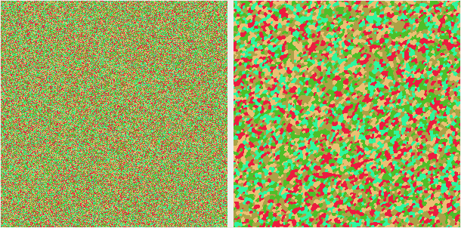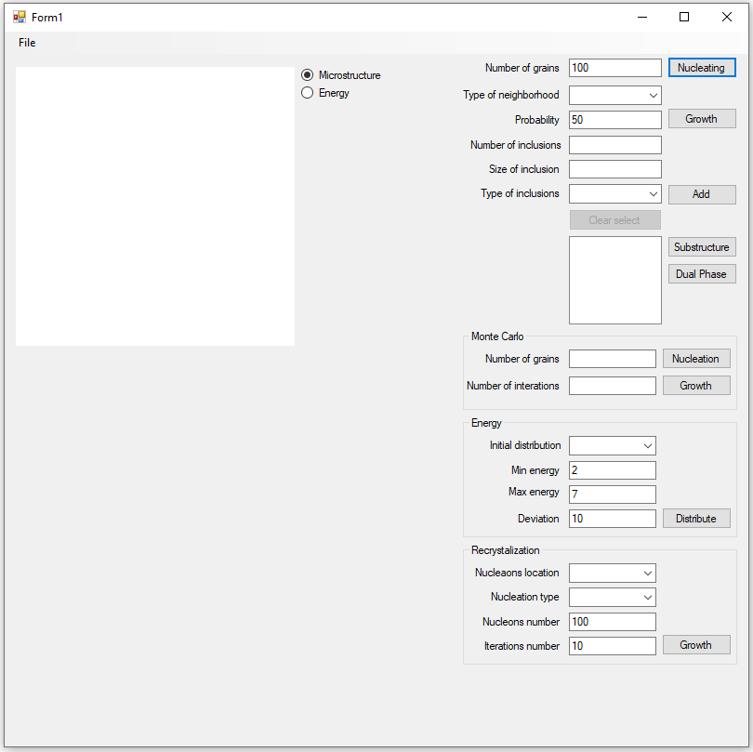

Image 2 Monte Carlo grains growth.

Image Application main window.

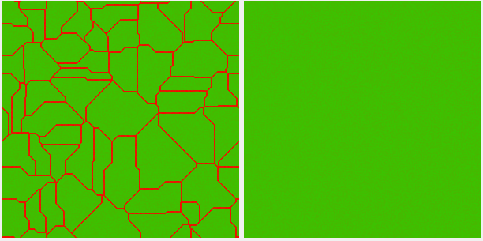Recrystalization group box let user perform recrystallization with given number of iterations and nucleons, its location (grain boundaries or anywhere) and nucleation type (constant, increasing or instant).

Image 3 Energy distribution.

**Examples of simulation results**

Example 1

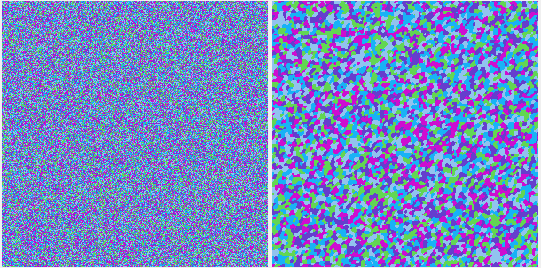First example show microstructure growth using Monte Carlo method. Initial structure contains 5 grains, each cell is assigned to random grain. Then the number of each cell, chosen in a random order, is changed to a different random number. The energy of the cell is calculated before and after the change and if the energy is lower after the change, the new grain number is accepted. Random cell picking is performed until all cells were taken under consideration, which means that iteration has ended and next one can begin. Image 4 shows microstructure before simulation and after 10 iterations. Each iteration causes the grains to grow larger and their boundaries to become smoother. Even after first ten iterations the microstructure looks quite realistic.

Image 4 Microstructure before and after MC growth.

The grains are still very small, but in some cases it may be desirable. While manipulating the number of grains and number of iterations, user can achieve a lot of different microstructures.

Example 2

This example show microstructure generated by combining Monte Carlo method with Shape control grain growth. Image 5 show microstructure generated by Monte Carlo growth (5 grains, 10 iterations), then one grain selected as a part of dual-phase microstructure and then the same microstructure after nucleating 100 new nucleons and growing them with shape control probability of 50%.

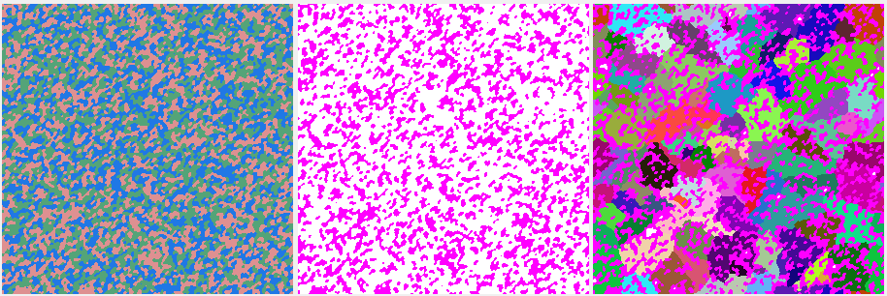Example 3

Image 5 Microstructure generated by combining Monte Carlo and shape control methods.

This example show microstructure generated by recrystalization on structure created by simple grain growth. Image 6 show microstructure generated by simple grain growth of 30 nucleons and image of its energy after distributing it homogenously. Image 7 show same microstructure and energy after 5 iterations of recrystallization. Before recrystallization, 100 new nucleons were placed randomly across entire structure. Image 8 show microstructure and energy after all cells has recrystallized. As expected, microstructure contain randomly placed grains with similar size.

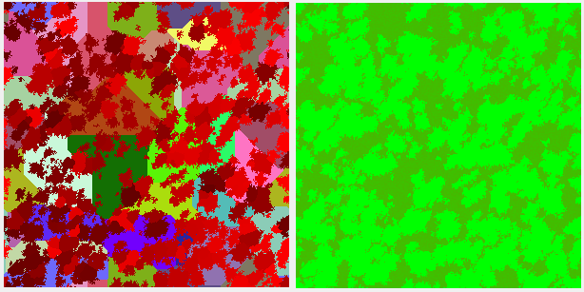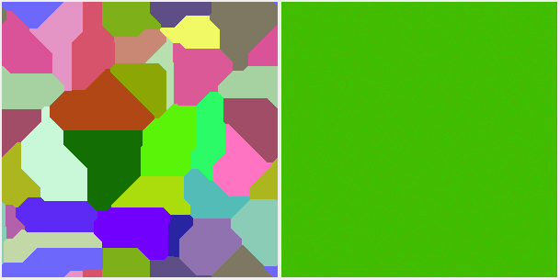

Image 7 Microstructure and its energy during recrystalization.

Image 6 Microstructure and its energy.

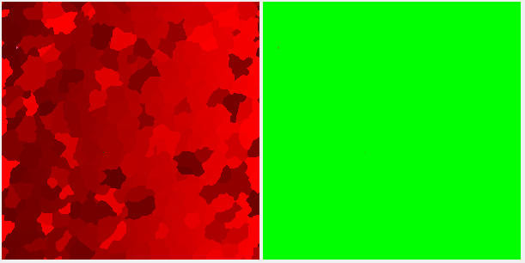Example 4

Image 8 Microstructure and its energy after recrystalization.

In these example initial microstructure was created similar to the one above and is shown on image 9, but energy was distributed heterogeneously, which means that energy is higher on grains boundaries than inside of the grain. In these example new nucleons were set only on grains boundaries. Image 10 show structure and energy after first 5 iterations of recrystallization. New grains are growing almost only on old grains boundaries, absorbing energy accumulated in grains. Image 11 show same microstructure and energy after next 10 iterations, when new grains has absorbed all boundaries and are finally filling the rest of cells.

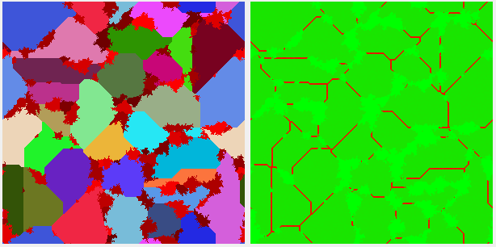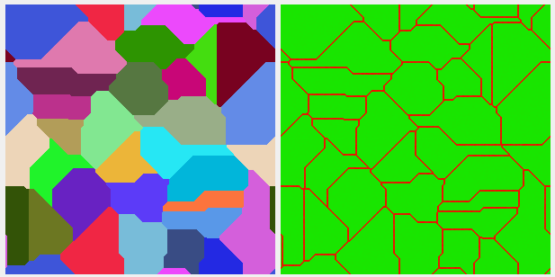

Image 10 Microstructure and energy during recrystalization.

Image 9 Microstructure and energy before recrystalization.

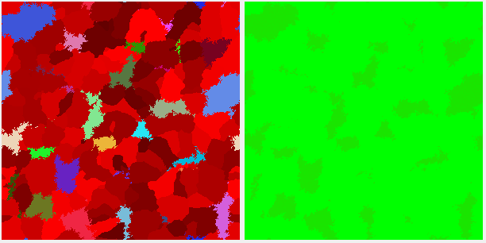

Image 11 Microstructure and energy at the end of recrystalization.

**Comparison with real microstructure:**

**Bake hardening steel:**

Image 12 show real microstructure created by ArceloMittal [(https://automotive.arcelormittal.com/saturnus/sheets/images/large/Microstructure)](https://automotive.arcelormittal.com/saturnus/sheets/images/large/Microstructure) compared to one generated by Monte Carlo method, starting with X grains and processing for 25 iterations.

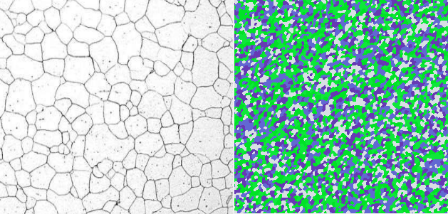

Image 12 Real microstructure compared to artificial one.

Conclusion:

Artificial microstructure is quite similar to the real one. Grains have different size and irregular shape, but boundaries are very smooth. It wold be very hard to achieve similar results with Moore grains growth, because in Moore method all grains have similar size and boundaries are jagged. To sum up, in Monte Carlo grain growth algorithm one can generate real-looking microstructures just by manipulating the initial number of grains and the number of iterations. The only drawback of this approach is that the resultant position of each grain can not be influenced as the method is fully random.

**Dual-phase steel:**

Image 13 show real microstructure of dual-phase steel created in West Pomeranian University of Technology Szczecin (<https://kundoc.com/pdf-dual-phase-steels-microstructure-and-properties-consideration-based-on-artificia.html>) compared to the one generated using Simple grain growth and then Monte Carlo method.

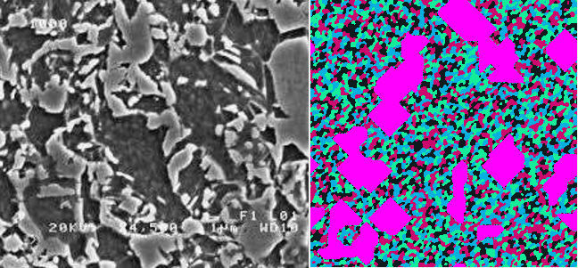Conclusion:

Image 13 Real microstructure compared to artificial one.

Generated structure looks somewhat similar to real one. It is very easy to recreate dark area of small grains. The only disadvantage is the same as in the previous example. The final position and shape of the grains can not be controlled. The bright area is more problematic, because it has to be manually chosen from generated grains, so large number of small grains require some patience during creating artificial microstructure.

**Carbon steel after annealing:**

Image 14 show comparison between real microstructure of steel created at Univeristy of Trento (<https://www.researchgate.net/figure/Metallographic-images-of-AISI-a-1015-b-1035-c-1045-and-d-1080-steel-after_fig1_257712636>) and artificial one created by Simple grain growth and recrystallizing that structure (heterogenous energy distribution and nucleons only on grains boundaries).

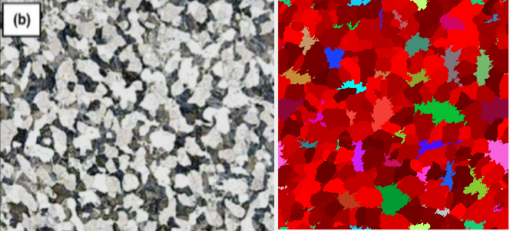Conclusion:

Image 14 Real microstruvture compared to artificial one.

Structure generated in this example does not look very similar to the original one. Grains boundaries are very jagged and it is hard to control size and shape of recrystallized grains. However Static recrystallization make it easy to create structure with grains at the boundaries. It is possible to make new grains grow faster at the old grains boundaries than into old grains by manipulating energy distribution.

**General conclusion:**

Adding Monte Carlo algorithm to the project significantly extended its possibilities. Some of the simulations provided better results then when simple transition rules were used. The combination of Monte Carlo and previously implemented methods is a very powerful tool enabling one to generate a lot of different microstructures in much easier way than in the previous part of the project. Now generating more complicated structures does not require so much manipulation of the parameters, since in Monte Carlo there are only two variables: initial number of grains and the number of iterations. However the recrystallization part has some limitations. Because of its simplified form, the algorithm provides the microstructures that only partially resemble the original ones. Perhaps changing the way that the energy is distributed and how it influence the nucleation would make the results more reliable.